Difference between composition and aggregation?
without existing container object if there is no chance of existing contained object then container and container object are strongly associated and this strong association is nothing but composition
example- university consist of several departments, without existing of university there is no chance of existing department hence university and department are strongly associated and this strong association is nothing but composition.
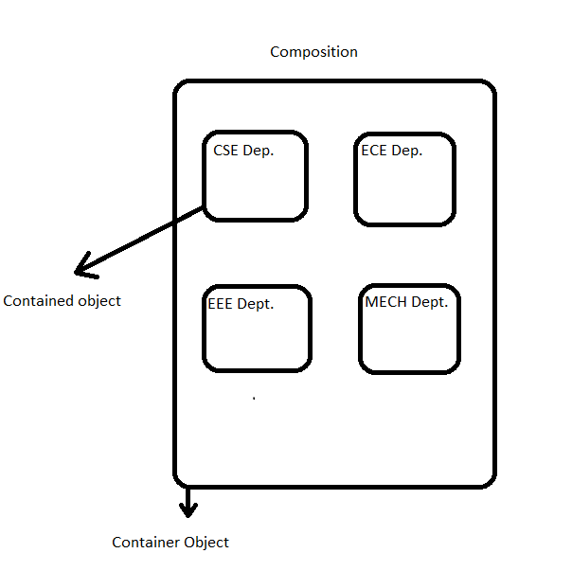
Aggregation: without existing container object if there is a chance of existing contained object then container and contained objects are weakly associated and this weak association is nothing but aggregation.
example-
department consist of several professors, without existing department there may be a chance of existing professor object hence department and professor objects are weakly associated and this weak association is nothing but aggregation.
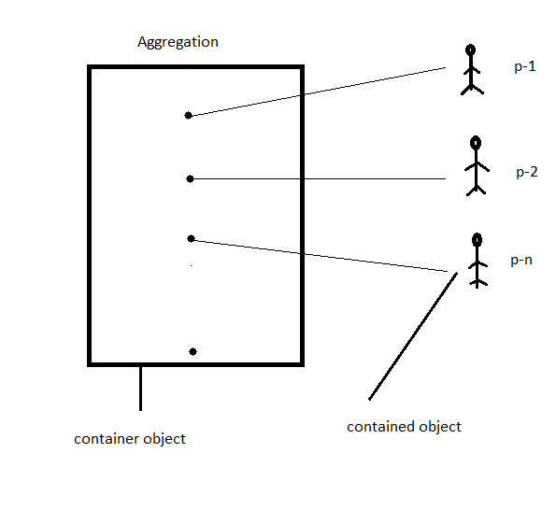
IS-A vs HAS-A
if you want total functionality of a class automatically then we should go for IS-A relationship.
Example:
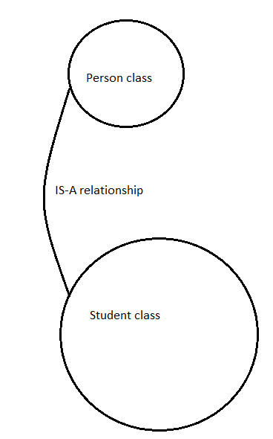
if we want part of the functionality then we should go for HAS-A relationship
Example:
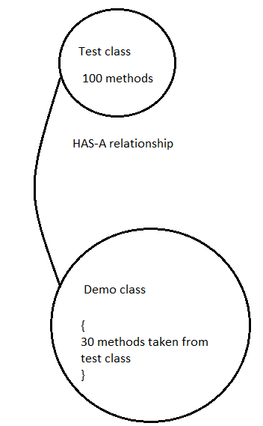
Method Signature:
In java method signature consist of method name followed by arguments types:|
example:
public static int m1(int I, float f)---→ m1(int,float).

